Technical Code Appendix
Classical Forecasting and XGBoost Machine Learning Forecasting
DATA 624 – Group 1 Project 1
Bonus #1 – Option #2: Modern ML / Deep Learning Forecasting Comparison
Prepared by: Barakat Adigun, Blessing Anoroh, Denise Atherley, Brandon Chanderban

This bonus will serve to extend the Exercise #2 HealthLink forecasting workflow by way of applying a modern machine learning model to the same monthly clinic-visit dataset. Moreover, since the bonus requires ML forecasts for each clinic and the system total, along with a comparison against the classical forecasting workflow, the code below shall first recreate the core data preparation steps from Exercise #2 before fitting and evaluating an XGBoost model.
# Load the packages required for data preparation, forecasting, machine learning, visualization, and model evaluation.
library(tidyverse)
library(lubridate)
library(tsibble)
library(fable)
library(feasts)
library(fabletools)
library(slider)
library(xgboost)
library(patchwork)

Data Import and Preparation
In this section, the HealthLink dataset is imported from the group’s public GitHub repository in order to preserve reproducibility. The monthly date field is converted into a usable time index, and a COVID shock indicator is created to mirror the structure originally utilized with the Exercise #2 workflow.
# Store the public GitHub URL so that the workflow can be reproduced without relying upon a local file path.
url <- "https://raw.githubusercontent.com/DRA-SPS27/DATA-624---Group-1-Project-1/refs/heads/main/student%20texas%20healthlink%20raw.csv"
# Import the HealthLink dataset from the public repository.
raw_data <- read_csv(url, show_col_types = FALSE)
# Clean the raw data, convert the month field into a monthly time index, and create the COVID shock indicator used in the forecasting models.
hl_data <- raw_data %>%
mutate(
month_date = mdy(month),
Month = yearmonth(month_date),
covid_shock = if_else(
month_date >= ymd("2020-03-01") & month_date <= ymd("2021-02-28"),
1, 0
)
) %>%
select(clinic, Month, month_date, visits, covid_shock) %>%
arrange(clinic, Month)
# Convert the cleaned dataset into a tsibble for time-series modeling.
hl_tsibble <- hl_data %>%
select(clinic, Month, visits, covid_shock) %>%
as_tsibble(index = Month, key = clinic)
# Create the clinic hierarchy so that forecasts can be evaluated at both the clinic level and the system-wide level.
hl_hierarchy <- hl_tsibble %>%
aggregate_key(clinic, visits = sum(visits), covid_shock = max(covid_shock))

Classical Forecasting Benchmark
The following chunk of code serves to recreate the classical benchmark models from within Exercise #2. ETS, ARIMA with a COVID dummy, and also TSLM are trained on the 2016 to 2022 period and evaluated against the 2023 holdout year. This in turn provides a baseline against which the ML model will later be compared.
# Split the data into training and testing periods. Models are trained through 2022 and validated against 2023.
train_data <- hl_hierarchy %>%
filter_index(. ~ "2022-12")
test_data <- hl_hierarchy %>%
filter_index("2023-01" ~ "2023-12")
# Fit the classical benchmark models used for comparison: ETS, ARIMA with the COVID shock variable, and TSLM.
fit_models <- train_data %>%
model(
ets = ETS(visits),
arima = ARIMA(visits ~ covid_shock),
tslm = TSLM(visits ~ trend() + season() + covid_shock)
)
# Apply MinT reconciliation to the ARIMA model so clinic-level forecasts remain consistent with the system-wide total.
reconciled_models <- fit_models %>%
mutate(
mint_arima = min_trace(arima, method = "mint_shrink")
)
# Create the future data frame required for models using the COVID indicator.
future_2023 <- test_data %>%
select(clinic, Month, covid_shock)
# Generate forecasts for the 2023 holdout period.
fc_test <- reconciled_models %>%
forecast(new_data = future_2023)
# Calculate accuracy measures for the classical models.
classical_accuracy <- accuracy(fc_test, hl_hierarchy) %>%
as_tibble() %>%
select(.model, clinic, RMSE, MAE, MAPE)
print(classical_accuracy)
# A tibble: 24 × 5
.model clinic RMSE MAE MAPE
<chr> <chr*> <dbl> <dbl> <dbl>
1 arima Belton 38.9 31.6 2.45
2 arima HarkerHeights 36.6 28.8 2.69
3 arima Killeen 44.2 35.5 1.91
4 arima Temple 90.6 72.4 2.77
5 arima Waco 71.6 60.6 2.59
6 arima <aggregated> 158. 138. 1.50
7 ets Belton 31.4 24.2 1.89
8 ets HarkerHeights 29.6 21.8 2.02
9 ets Killeen 46.7 39.3 2.09
10 ets Temple 38.2 30.8 1.20
# ℹ 14 more rows

Feature Engineering for the ML Model
Unlike the case with the ARIMA and ETS models, XGBoost does not automatically understand the time-series structure. As such, the time-series information thus has to be translated into features such as lagged visits, rolling averages, month indicators, year indicators, and the COVID shock variable.
# Define a function to create the features required for XGBoost. These include calendar variables, lagged visits, and rolling averages.
create_ml_features <- function(data) {
data %>%
arrange(clinic, Month) %>%
group_by(clinic) %>%
mutate(
month_num = month(as.Date(Month)),
year_num = year(as.Date(Month)),
time_index = row_number(),
lag_1 = lag(visits, 1),
lag_2 = lag(visits, 2),
lag_3 = lag(visits, 3),
lag_6 = lag(visits, 6),
lag_12 = lag(visits, 12),
roll_mean_3 = slide_dbl(visits, mean, .before = 2, .complete = TRUE),
roll_mean_6 = slide_dbl(visits, mean, .before = 5, .complete = TRUE)
) %>%
ungroup()
}
# Apply the feature engineering function and remove rows with missing values that are created by the lag and rolling average calculations.
ml_data <- create_ml_features(hl_data) %>%
drop_na()
# Use observations through 2022 to train the ML model.
train_ml <- ml_data %>%
filter(Month <= yearmonth("2022 Dec"))

XGBoost Model Training
The following chunk fits a global XGBoost model across all of the clinics. Instead of fitting a separate model for each of the clinics, the clinic name shall be included as a predictor, thus allowing the model to learn both system-wide patterns and clinic-specific differences.
# Specify the predictor set used by the XGBoost model. The clinic field is included so one global model can learn clinic-specific patterns.
x_formula <- ~ clinic + month_num + year_num + time_index + covid_shock +
lag_1 + lag_2 + lag_3 + lag_6 + lag_12 + roll_mean_3 + roll_mean_6
# Convert the predictor variables into a numeric matrix required by xgboost.
x_train <- model.matrix(x_formula, data = train_ml)[, -1]
y_train <- train_ml$visits
# Set a seed so that the model training results are reproducible.
set.seed(624)
# Train the XGBoost regression model using squared error loss.
xgb_fit <- xgboost(
data = x_train,
label = y_train,
nrounds = 250,
max_depth = 3,
eta = 0.05,
subsample = 0.85,
colsample_bytree = 0.85,
objective = "reg:squarederror",
verbose = 0
)

Recursive Forecasting Functions
Because the future lagged values are not known in advance, the ML forecasts are as such generated recursively. In this, each predicted month is added back into the history and then used to construct the features for the next forecast month.
# Create one row of future features for each clinic for a given forecast month.
make_future_features <- function(history_data, forecast_month) {
# Ensure the forecast month is stored using the same yearmonth format as the historical data.
forecast_month <- yearmonth(forecast_month)
map_dfr(unique(history_data$clinic), function(clinic_name) {
# Pull the historical data for the clinic being forecasted.
clinic_history <- history_data %>%
filter(clinic == clinic_name) %>%
arrange(Month)
tibble(
clinic = clinic_name,
Month = forecast_month,
month_date = as.Date(forecast_month),
covid_shock = 0,
month_num = month(as.Date(forecast_month)),
year_num = year(as.Date(forecast_month)),
time_index = nrow(clinic_history) + 1,
lag_1 = tail(clinic_history$visits, 1),
lag_2 = tail(clinic_history$visits, 2)[1],
lag_3 = tail(clinic_history$visits, 3)[1],
lag_6 = tail(clinic_history$visits, 6)[1],
lag_12 = tail(clinic_history$visits, 12)[1],
roll_mean_3 = mean(tail(clinic_history$visits, 3)),
roll_mean_6 = mean(tail(clinic_history$visits, 6))
)
})
}
# Generate multi-step forecasts recursively. Each predicted month is appended to the history and then used to forecast the following month.
recursive_xgb_forecast <- function(history_data, start_month, h = 12) {
# Create the sequence of future months to be forecasted.
forecast_months <- yearmonth(start_month) + 0:(h - 1)
history_extended <- history_data
forecast_output <- tibble()
for (i in seq_along(forecast_months)) {
m <- yearmonth(forecast_months[i])
# Build features for the current forecast month using the latest available history.
new_features <- make_future_features(history_extended, m)
x_new <- model.matrix(x_formula, data = new_features)[, -1]
# Generate XGBoost predictions for the current forecast month.
predictions <- predict(xgb_fit, x_new)
month_forecast <- new_features %>%
mutate(
Month = yearmonth(Month),
predicted_visits = round(predictions, 0)
) %>%
select(clinic, Month, predicted_visits)
forecast_output <- bind_rows(forecast_output, month_forecast)
# Add the newly forecasted values back into the history so they can be used as lagged inputs for later forecast months.
history_extended <- bind_rows(
history_extended,
month_forecast %>%
mutate(
Month = yearmonth(Month),
visits = predicted_visits,
month_date = as.Date(Month),
covid_shock = 0
) %>%
select(clinic, Month, month_date, visits, covid_shock)
)
}
forecast_output
}

ML Validation on the 2023 Holdout Data
Next, the model is tested against the 2023 holdout period data in order to compare its accuracy to the classical models. This in turn mirrors the validation approach executed within Exercise #2.
# Use data through 2022 as the historical base for validating 2023 forecasts.
history_through_2022 <- hl_data %>%
filter(Month <= yearmonth("2022 Dec"))
# Produce recursive XGBoost forecasts for the 2023 holdout period.
xgb_2023_forecast <- recursive_xgb_forecast(
history_data = history_through_2022,
start_month = "2023 Jan",
h = 12
)
# Extract the actual 2023 visits for comparison against the ML forecasts.
actual_2023 <- hl_data %>%
filter(Month >= yearmonth("2023 Jan"),
Month <= yearmonth("2023 Dec")) %>%
select(clinic, Month, actual_visits = visits)
# Calculate clinic-level ML accuracy measures for 2023.
xgb_2023_accuracy <- xgb_2023_forecast %>%
left_join(actual_2023, by = c("clinic", "Month")) %>%
group_by(clinic) %>%
summarise(
RMSE = sqrt(mean((actual_visits - predicted_visits)^2)),
MAE = mean(abs(actual_visits - predicted_visits)),
MAPE = mean(abs((actual_visits - predicted_visits) / actual_visits)) * 100,
.groups = "drop"
) %>%
mutate(.model = "xgboost")
# Sum clinic forecasts to the system level and calculate system-wide accuracy.
xgb_2023_system_accuracy <- xgb_2023_forecast %>%
group_by(Month) %>%
summarise(predicted_visits = sum(predicted_visits), .groups = "drop") %>%
left_join(
actual_2023 %>%
group_by(Month) %>%
summarise(actual_visits = sum(actual_visits), .groups = "drop"),
by = "Month"
) %>%
summarise(
clinic = "System Total",
RMSE = sqrt(mean((actual_visits - predicted_visits)^2)),
MAE = mean(abs(actual_visits - predicted_visits)),
MAPE = mean(abs((actual_visits - predicted_visits) / actual_visits)) * 100
) %>%
mutate(.model = "xgboost")
# Combine clinic-level and system-wide ML accuracy results.
xgb_accuracy <- bind_rows(xgb_2023_accuracy, xgb_2023_system_accuracy)
print(xgb_accuracy)
# A tibble: 6 × 5
clinic RMSE MAE MAPE .model
<chr> <dbl> <dbl> <dbl> <chr>
1 Belton 34.6 24.2 1.90 xgboost
2 HarkerHeights 40.0 30.6 2.87 xgboost
3 Killeen 55.3 46.9 2.49 xgboost
4 Temple 117. 102. 3.91 xgboost
5 Waco 50.0 38.1 1.62 xgboost
6 System Total 223. 192 2.09 xgboost

2024 ML Forecasts
After validation, the XGBoost model was used to generate the 12-month ahead forecasts for 2024. Forecasts are produced at the clinic level and then summed to obtain a system-wide format/outlook.
# Generate the final 12-month ahead XGBoost forecasts for 2024.
xgb_2024_forecast <- recursive_xgb_forecast(
history_data = hl_data,
start_month = "2024 Jan",
h = 12
)
# Aggregate clinic-level ML forecasts to produce the system-wide forecast.
xgb_2024_system <- xgb_2024_forecast %>%
group_by(Month) %>%
summarise(predicted_visits = sum(predicted_visits), .groups = "drop")
print(xgb_2024_forecast)
# A tibble: 60 × 3
clinic Month predicted_visits
<chr> <mth> <dbl>
1 Belton 2024 Jan 1338
2 HarkerHeights 2024 Jan 1055
3 Killeen 2024 Jan 1900
4 Temple 2024 Jan 2527
5 Waco 2024 Jan 2380
6 Belton 2024 Feb 1322
7 HarkerHeights 2024 Feb 1084
8 Killeen 2024 Feb 1928
9 Temple 2024 Feb 2515
10 Waco 2024 Feb 2438
# ℹ 50 more rows
print(xgb_2024_system)
# A tibble: 12 × 2
Month predicted_visits
<mth> <dbl>
1 2024 Jan 9200
2 2024 Feb 9287
3 2024 Mar 9281
4 2024 Apr 9003
5 2024 May 9062
6 2024 Jun 9215
7 2024 Jul 9183
8 2024 Aug 9074
9 2024 Sept 9076
10 2024 Oct 9075
11 2024 Nov 9052
12 2024 Dec 9085

2024 Forecast Summaries
The following tables summarize the 2024 ML forecasts by both the clinic and overall system levels. The outputs will be useful for the executive comparison document to be created since they provide facets such as the expected demand levels, the average monthly demand, and also the peak demand periods.
# Summarize total annual demand, average monthly demand, and peak demand for each clinic.
xgb_clinic_summary_2024 <- xgb_2024_forecast %>%
group_by(clinic) %>%
summarise(
forecast_2024_visits = sum(predicted_visits),
average_monthly_visits = mean(predicted_visits),
peak_month = Month[which.max(predicted_visits)],
peak_visits = max(predicted_visits),
.groups = "drop"
) %>%
arrange(desc(forecast_2024_visits))
# Summarize the same forecast information at the system-wide level.
xgb_system_summary_2024 <- xgb_2024_system %>%
summarise(
forecast_2024_total = sum(predicted_visits),
average_monthly_visits = mean(predicted_visits),
peak_month = Month[which.max(predicted_visits)],
peak_visits = max(predicted_visits),
lowest_month = Month[which.min(predicted_visits)],
lowest_visits = min(predicted_visits)
)
print(xgb_clinic_summary_2024)
# A tibble: 5 × 5
clinic forecast_2024_visits average_monthly_visits peak_month peak_visits
<chr> <dbl> <dbl> <mth> <dbl>
1 Temple 29782 2482. 2024 Jan 2527
2 Waco 28803 2400. 2024 Jul 2461
3 Killeen 22583 1882. 2024 Feb 1928
4 Belton 15619 1302. 2024 Jan 1338
5 HarkerHeig… 12806 1067. 2024 Mar 1111
print(xgb_system_summary_2024)
# A tibble: 1 × 6
forecast_2024_total average_monthly_visits peak_month peak_visits lowest_month
<dbl> <dbl> <mth> <dbl> <mth>
1 109593 9133. 2024 Feb 9287 2024 Apr
# ℹ 1 more variable: lowest_visits <dbl>

Comparison of Accuracy: Classical vs. ML
This next section will serve to compare the XGBoost model against the classical forecasting models from within Exercise #2. Since the comparison will be done based upon the 2023 holdout accuracy, it will allow for a fairer basis for evaluating whether or not the ML model offered an actual improved forecasting performance.
# Average the classical model accuracy results across clinics and the system total.
classical_summary <- classical_accuracy %>%
group_by(.model) %>%
summarise(
RMSE = mean(RMSE, na.rm = TRUE),
MAE = mean(MAE, na.rm = TRUE),
MAPE = mean(MAPE, na.rm = TRUE),
.groups = "drop"
)
# Summarize XGBoost accuracy in the same format as the classical models.
xgb_summary <- xgb_accuracy %>%
summarise(
.model = "xgboost",
RMSE = mean(RMSE, na.rm = TRUE),
MAE = mean(MAE, na.rm = TRUE),
MAPE = mean(MAPE, na.rm = TRUE)
)
# Combine classical and ML accuracy summaries for direct comparison.
accuracy_comparison <- bind_rows(classical_summary, xgb_summary) %>%
arrange(RMSE)
print(accuracy_comparison)
# A tibble: 5 × 4
.model RMSE MAE MAPE
<chr> <dbl> <dbl> <dbl>
1 tslm 50.8 40.3 1.58
2 ets 54.4 44.4 1.76
3 arima 73.4 61.1 2.32
4 mint_arima 73.8 60.2 2.23
5 xgboost 86.6 72.3 2.48

Forecast Visualizations
These final plots will aim to visualize the 2024 XGBoost forecasts by clinic and for the system as a whole. The graphics are intended to buttress the executive-facing comparison by showing how the ML model projects future demand.
# Plot the 2024 XGBoost forecasts separately for each clinic.
p_xgb_clinic <- xgb_2024_forecast %>%
ggplot(aes(x = as.Date(Month), y = predicted_visits)) +
geom_line() +
geom_point() +
facet_wrap(~ clinic, scales = "free_y") +
labs(
title = "XGBoost 12-Month Patient Demand Forecast by Clinic (2024)",
x = "Month",
y = "Predicted Visits"
) +
theme_minimal()
# Plot the 2024 system-wide XGBoost forecast.
p_xgb_system <- xgb_2024_system %>%
ggplot(aes(x = as.Date(Month), y = predicted_visits)) +
geom_line() +
geom_point() +
labs(
title = "XGBoost 12-Month System-Wide Patient Demand Forecast (2024)",
x = "Month",
y = "Predicted Total Visits"
) +
theme_minimal()
print(p_xgb_clinic)

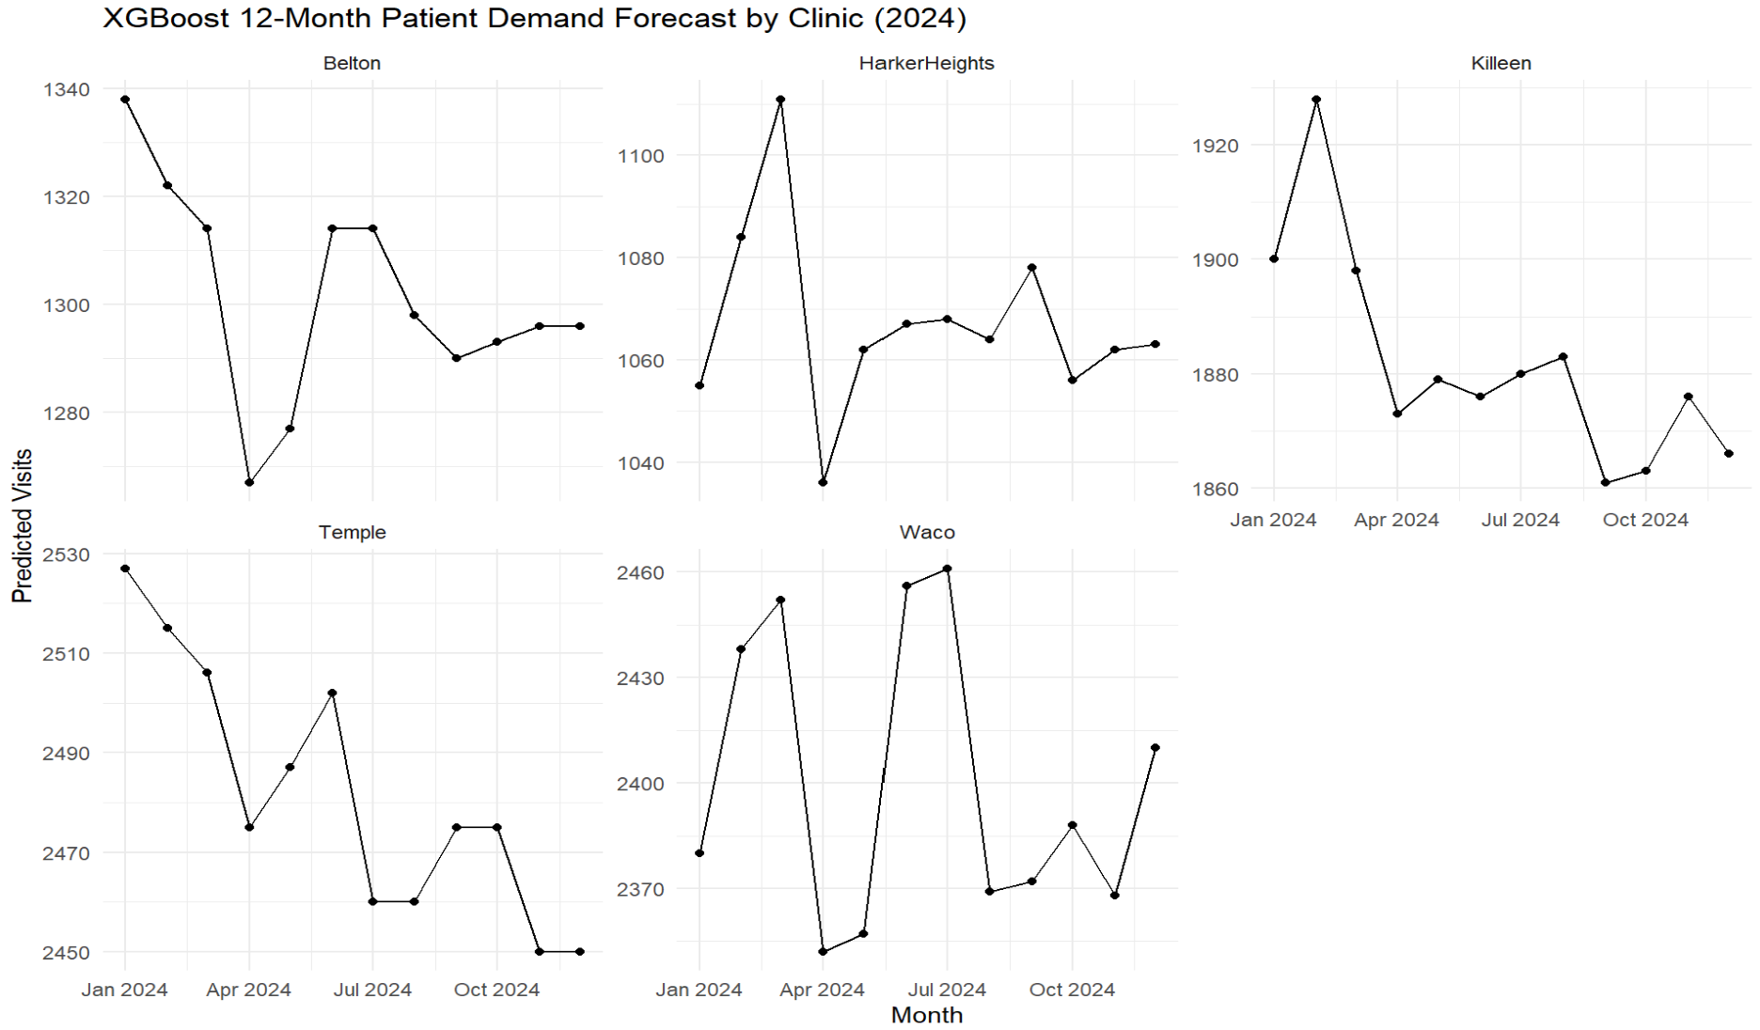

print(p_xgb_system)
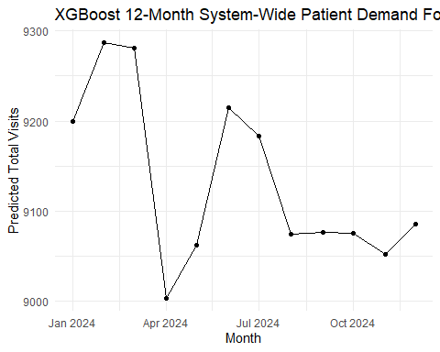

Variable Importance
Finally, the variable importance output will be produced to provide some interpretability around the XGBoost model. Whilst XGBoost may be interpreted as somewhat less transparent than ARIMA or ETS, this output helps indicate which of the engineered features contributed most heavily to the model’s predictions.
# Calculate variable importance to identify which engineered features contributed most to the XGBoost model.
importance_matrix <- xgb.importance(
feature_names = colnames(x_train),
model = xgb_fit
)
print(importance_matrix)
Feature Gain Cover Frequency
<char> <num> <num> <num>
1: roll_mean_3 5.922264e-01 0.2326852105 0.200948429
2: roll_mean_6 3.294189e-01 0.1427739308 0.101363367
3: lag_12 4.687886e-02 0.0836908659 0.086544161
4: lag_6 2.122234e-02 0.0845950211 0.094842916
5: lag_1 2.924686e-03 0.0707805728 0.100177830
6: month_num 2.101780e-03 0.1248255806 0.113811500
7: clinicKilleen 1.594051e-03 0.0021473686 0.005334914
8: lag_2 1.357257e-03 0.0994179501 0.119739182
9: time_index 1.145745e-03 0.0947971954 0.084173088
10: lag_3 4.952242e-04 0.0505674878 0.060462359
11: year_num 3.578990e-04 0.0033862351 0.009484292
12: covid_shock 2.304265e-04 0.0051858517 0.011855365
13: clinicTemple 2.179625e-05 0.0032036653 0.005334914
14: clinicWaco 1.721654e-05 0.0017300662 0.002963841
15: clinicHarkerHeights 7.403497e-06 0.0002129981 0.002963841
# Visualize the feature importance results.
xgb.plot.importance(importance_matrix)
